Lab 6 – Common-emitter amplifier

Names: Evan Wilson, Cohlten Green, Jonathan Johnston
Date: 11/14/2017

Design schematic to meet design inputs of Vin = 10mVpp, Vout = 100mVpp, Freq = 1KHz, Vcc = 9VDC,
RL = 1K

Equipment and parts needed: 22kΩ resistor, 220kΩ resistor, 4 - 100Ω resistors, 1kΩ resistor, 2 – 1uF Capacitors, 47uF Capacitor, 2N2222A Transistor, DC Power source, Function generator, Oscilloscope, and digital multi meter.

Resistor Values
Expected Measured
22kΩ 22.053kΩ
220kΩ 206.953kΩ
100Ω 98.39Ω
100Ω 98.15Ω
100Ω 98.63Ω
100Ω 98.55Ω
1kΩ .983kΩ

Capacitor Values
Expected Measured
1uF 1.053uF
1uF .876uF
47uF 46.65uF
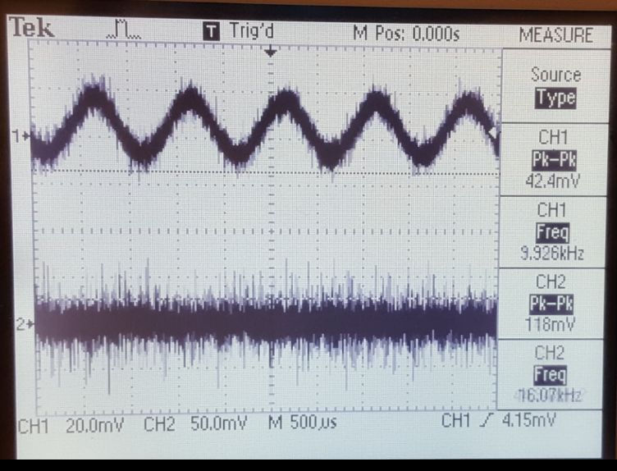
Observations: We tested it several times and were unable to come up with the proper measurements. We found that we had wired in one of the resistors incorrectly, once corrected we were able to get the proper reading off of the oscilloscope.

