Lab #5 – Transistor circuit

Names: Evan Wilson, Cohlten Green
Date: 10/31/2017

Build a transistor circuit that turns on and off an LED:

Equipment and parts needed: LED, Breadboard, Function Generator, Multimeter, DC Power Supply, 2x 220 Ohm Resistors, 2N2222A NPN Transistor.

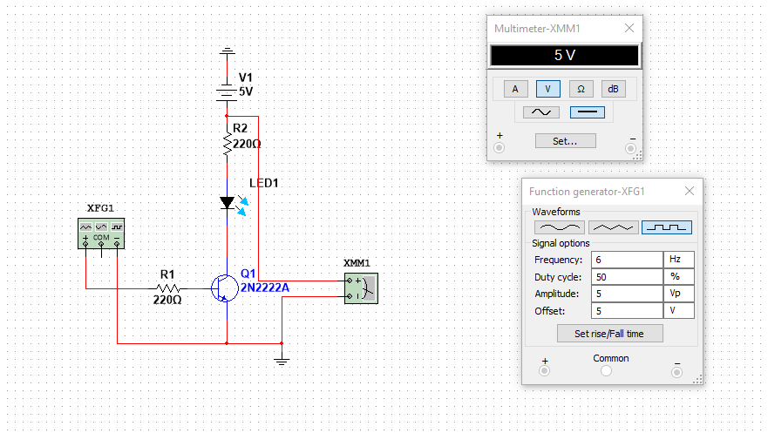

Observations: When we first built the circuit in multisim we were getting a negative 5v output and had to switch the LED around to get the light to flash properly. We then realized that we need to switch the DC voltage positive and negative around to get the proper 5v output and have the LED blight properly positive to negative. We had a few issues figuring out which leg was 1 and 3 on the transistor, after we figured that out the LED flashed properly in our built circuit as well.

