Kevin Keating

Kkeating3@ivytech.edu

PhysicsII-(PHYS102-11R-B1-201320)

**Submission ( October 21, 2013 4:54:23 PM EDT )**

**Experiment: Combination of Resistors**

**Introduction:**

This experiment creates both series and parallel circuitry using this applet. This will demonstrate when resistors are connected in series, the sum of the voltage drops across each resistor will be equivalent to the total voltage developed by the source (the battery). The equivalent value is the sum fo the individual resistances.

ie: Re= R1 + R2 + R3 + ….

When resistors are connected in parallel, the sum of the currents across each resistor is equivalent to the total current passing through the battery. The equivalent resistance is given by:

+ ….

**Procedure:**

1. Load up the Java Lab from the web <http://www.walter-fendt.de/ph14e/combres.htm> .
2. A single 100-Ω resistor should appear in the circuit. Record the current (amperage) in the circuit.
3. Add a 50-Ω resistor in series by typing in 50 in the “Add Resistor” box, and then selecting the “Series Connection” box.
4. Record the current (amperage) in the circuit.
5. Record the voltage drop across each resistor by highlighting each resistor individually, and using the voltage meter selection. Determine the sum of the voltage drops, and compare this with the battery output.
6. Calculate the equivalent resistance, and compare this value to the one that is measured by the instruments (= V/I) where V is the voltage generated by the battery, and I is the measured current (amperage).
7. Add another 50-Ω resistor in series by typing in 50 in the “Add Resistor” box, and then again selecting the “Series Connection” box.
8. Record the current (amperage) in the circuit.
9. Record the voltage drop across each resistor by highlighting each resistor individually, and using the voltage meter selection. Determine the sum of the voltage drops, and compare this with the battery output.
10. Calculate the equivalent resistance, and compare this value to the one that is measured by the instruments (= V/I) where V is the voltage generated by the battery, and I is the measured current (amperage).
11. Reset the circuit so that only a single 100-Ω appears in the circuit.
12. Add a 50-Ω resistor in parallel by typing in 50 in the “Add Resistor” box, and then selecting the “Parallel Connection” box.
13. Record the voltage drop across each resistor.
14. Determine the current flowing through each resistor by selecting individually each resistor, and then selecting the amperage meter.
15. Record the total current (amperage) in the circuit by selecting the battery, and then selecting the amperage meter.
16. How does the sum of the currents in each part of the parallel circuit compare with the total current in the circuit?
17. Calculate the equivalent resistance, and compare this value to the one that is measured by the instruments (= V/I) where V is the voltage generated by the battery, and I is the total measured current (amperage).
18. Add another 50-Ω resistor in parallel by typing in 50 in the “Add Resistor” box, and then again selecting the “Parallel Connection” box.
19. Record the total current (amperage) in the circuit.
20. Calculate the equivalent resistance, and compare this value to the one that is measured by the instruments (= V/I) where V is the voltage generated by the battery, and I is the total measured current (amperage).

**Data and Observations:**

Step 2. A single 100-Ω resistor circuit has a current of 0.120 Amps

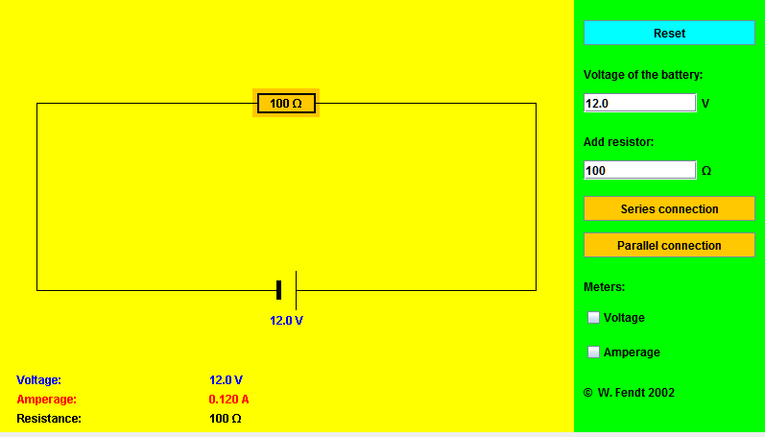

Step 4. Circuit with a 100-Ω resistor and a 50-Ω resistor in series has a current of 0.08 Amps

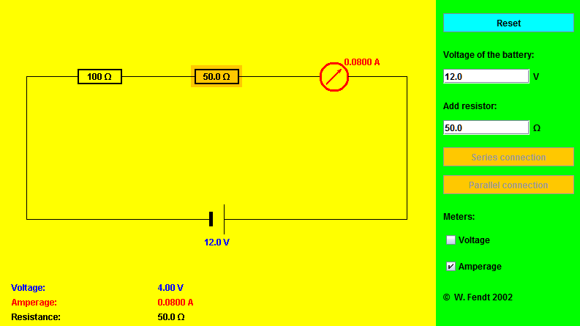

Step 5. The voltage drop for each resistor is:

100-Ω = 8.0 V

50-Ω = 4.0 V

Total = 12.0 V

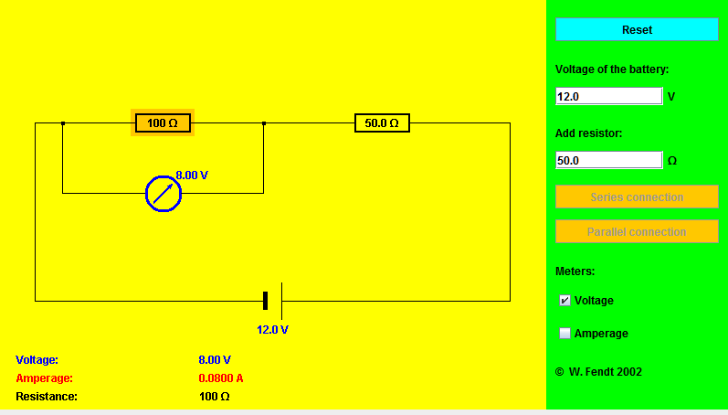

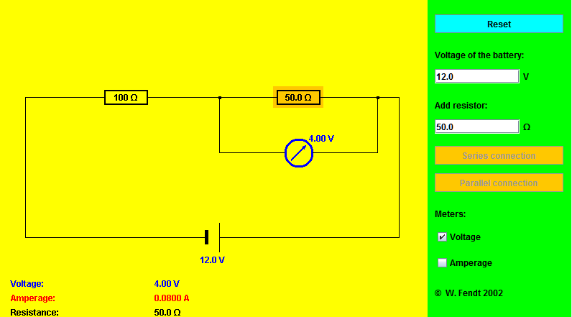

Step 6 The calculated equivalent for the series circuit resistance is:

150-Ω = 12 V/.08 A

Step 8.

Total Current = .06 Amps

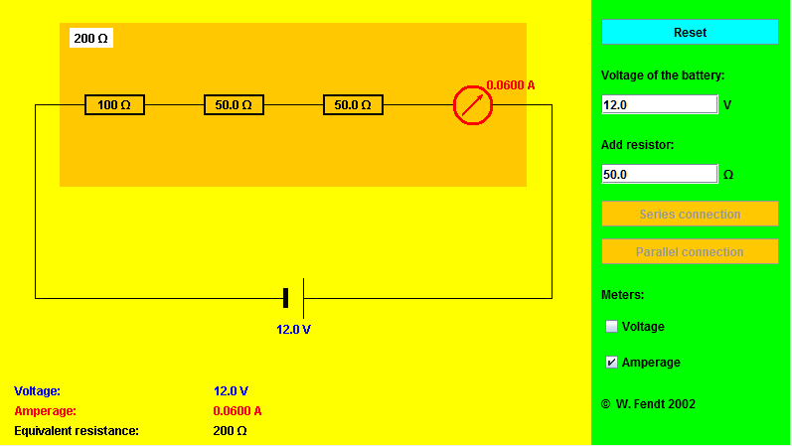

Step 9.

Voltage drop across each resistor:

100-Ω = 6.0 V

50-Ω = 3.0 V

50-Ω= 3.0 V

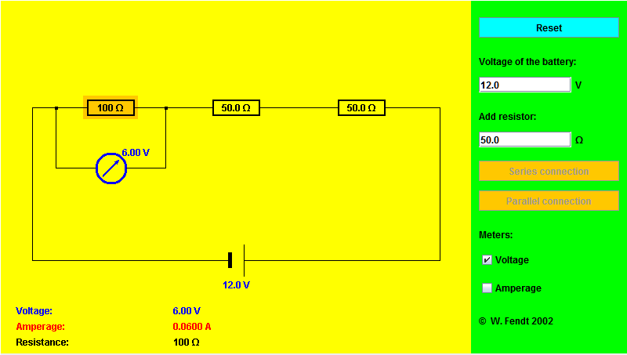

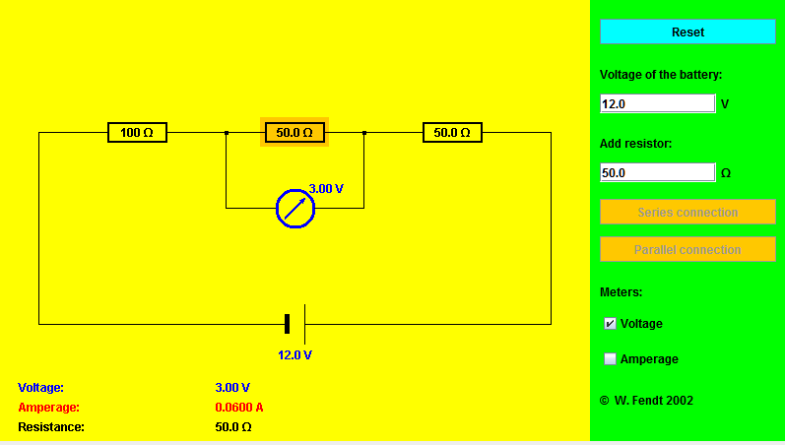

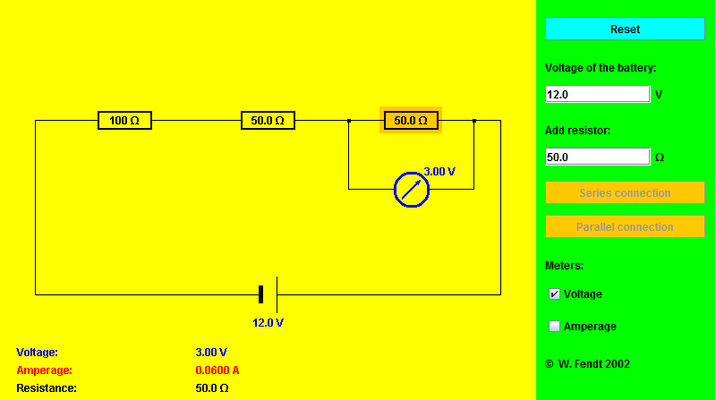

Step 11.

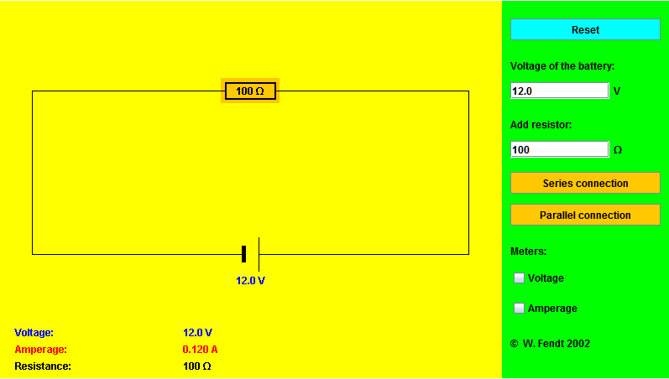

Step 12

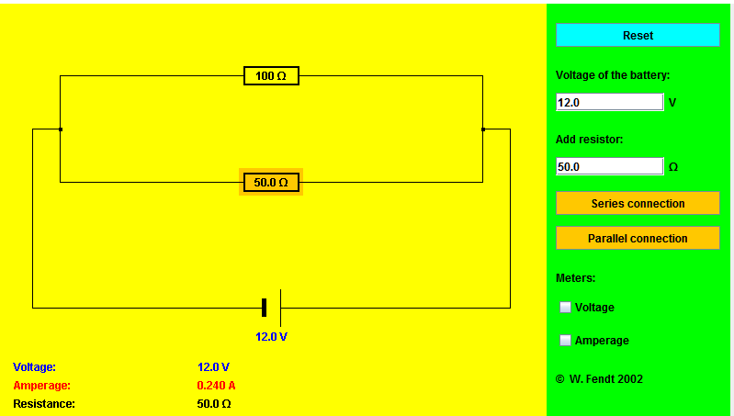

Step 13

Voltage Drop across resistors:

100-Ω = 12.0 V

50-Ω = 12.0 V

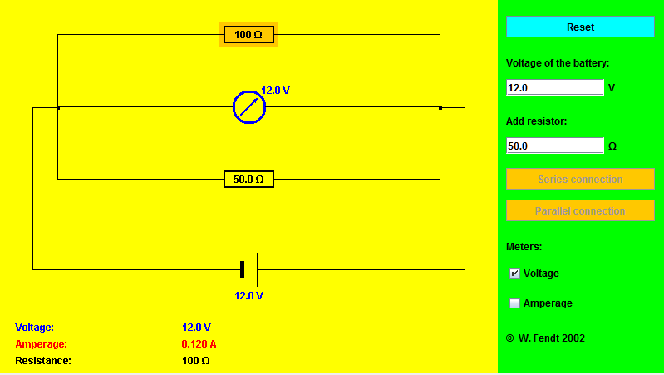

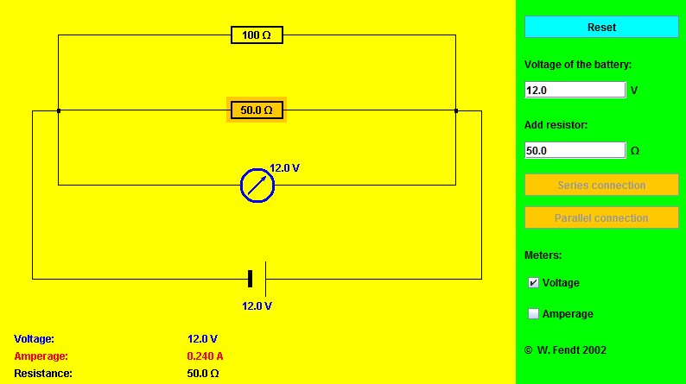

Step 14

Current flowing through each resistor:

100-Ω = 0.12 Amps

50-Ω = 0.24 Amps

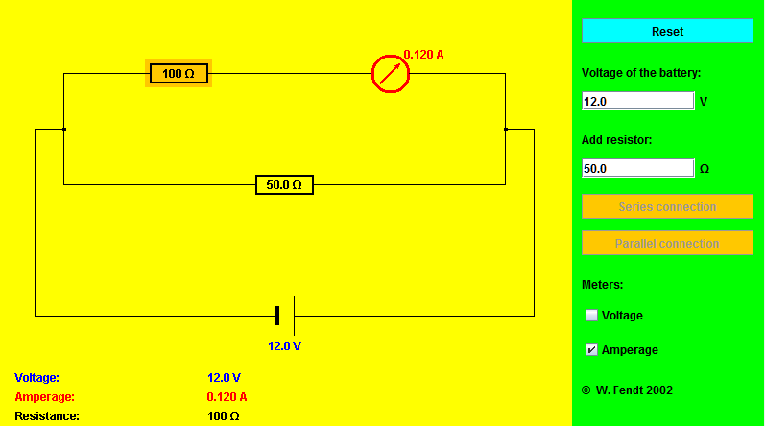

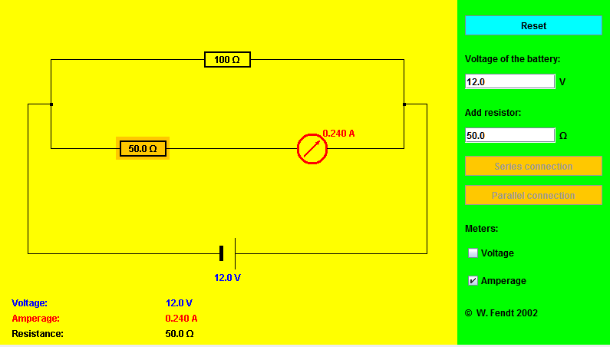

Step 15

Total Current in circuit = 0.36 Amps

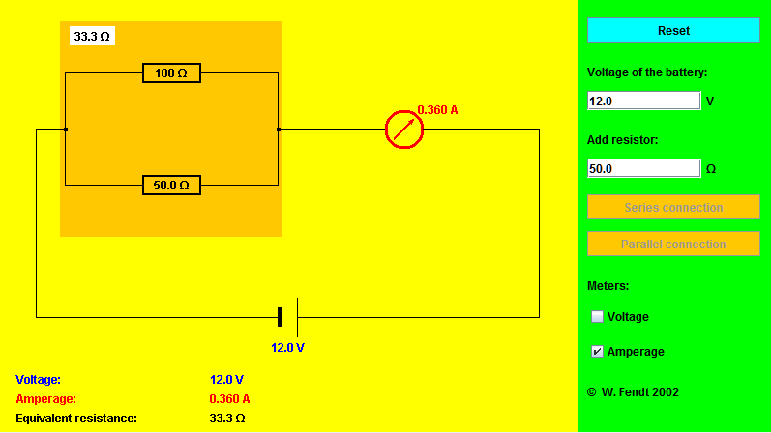

Step 16

The total sum of the currents in each part of the parallel circuit are equal with the total current in the circuit.

Step 17

The equivalent resistance = 33.3- Ω = 1/.03 = 1/100 +1/50

Step 19

Total Current Amperage = 0.60 Amps

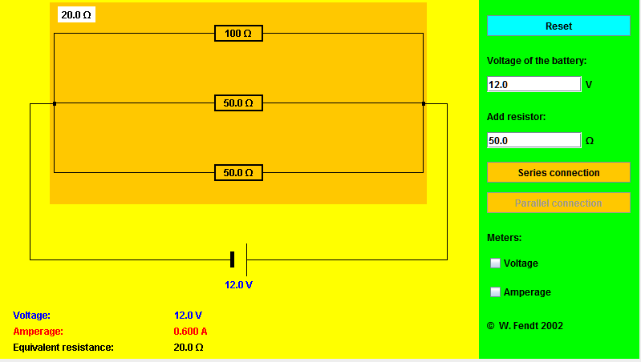

Step 20

The equivalent resistance = 20- Ω = 1/.05= 1/100 +1/50 + 1/50

**Conclusions:**

Ohms law is proven by electronically building circuits with resistors in series and in parallel and measuring both the currents and voltages at different points in the circuits. Additionally we can see that the formulas for calculating resistor equivalents for both series and parallel circuits work in practical applications.