Worst Case Analysis of Electronics
Using Parameter Design Techniques

Mr. Andrew G. Bell
Mrs. Catherine M. Vincent
ITT Industries, ACD
Fort Wayne, Indiana

October 2003

Abstract

For years circuit “robustness” has been determined though classical Extreme Value, Monte Carlo and Sensitivity Worst Case analyze (WCA). The amount of computer time needed to complete the circuit analysis could be quite long and costly based in part on the complexity of the circuit. Problems or errors with the simulations could also add more time.

An alternate WCA approach which uses Parameter Design Techniques for first order sensitivity analysis can be used to greatly shorten the total simulation time by focusing on a subset of the total number of possible circuit conditions and parameters. An appropriately sized Orthogonal Array is selected and experiments (simulations) are defined. The simulations are then executed and the results are collected and processed using an analysis of means to determine the factor effects. Then based upon the factor effects a confirmation simulation is run to predict the worst case performance. This paper will demonstrate the technique and compare the results to a classical WCA.

Introduction


ITT A/CD products include the U.S. Army SINCGARS and U.K. BOWMAN tactical communication system, voice data switches, data entry terminals, fiber optics transmission systems, ground to air radios used by the Federal Aviation Administration (FAA), and a family of secure communications terminals: space-based navigation and atmospheric remote sensing payloads—GPS, Alpha, GOES Imager/Sounder, AVHRR and HIRS Instruments. ITT Aerospace/Communications (A/CD) has facilities in Fort Wayne, Indiana and Clifton, New Jersey that employee 1,976 people. This presentation documents the “Parameter Design Technique” used on a space project power supply worse case analysis within the Fort Wayne headquarters.

Background

Worst Case Analysis (WCA) of electronic circuits has been a standard way of showing that a circuit meets the minimum design requirements as defined by the customer. The approach that is typically followed is to define worst case component variations based on temperature, aging, radiation and purchased tolerances.
Worst Case Analysis is defined here as a Monte Carlo Analysis or the Extreme Value Analysis based upon individual component parameter sensitivity.

The time it takes to run one of the multi-simulation analysis simulations can be quite long. Also, there is a probability that the simulation may fail to complete. Thus, engineering intervention to fix the problem may be required.

An alternate “Parameter Design Technique” approach which requires fewer simulations has been successfully used on one of ITT A/CD’s space programs to demonstrate a similar quality measurement in far less time.

Objectives

The intention of this paper is to show that the classical Worst Case Analysis can be successfully supplemented using Parameter Design Techniques. The method that will be used is to compare the Classical Worst Case Analysis approach against an alternate Parameter Design technique is to analyze
the maximum group delay performance of a simple 4 pole transitional Butterworth-Thompson filter.
All simulations were run on an UltraSPARC-II 400MHz Sun UNIX Workstation.

If simulation time can be reduced without loss of analysis quality: then from an engineering standpoint there could be a significant time savings, from a customer standpoint there could be a cost savings, and from a manager standpoint there could be similar design risk in less time and money.

Approach

A comparison was made between the Classical Worst Case Analysis approach and an alternate Parameter Design technique. The maximum group delay and circuit simulation time of a four pole transitional Butterworth-Thompson filter were used to compare the two techniques. This filter type is used in imaging equipment where time delay linearity is important.

Classical Approach

The Classical Approach tolerances all components based upon environmental and purchased parameters variations with a Gaussian distribution. Then an EVA Sensitivity/Worst Case and Monte Carlo Analysis are performed on the toleranced circuit and the circuit’s performance is measured. The results are then used to predict the worst case performance of the circuit.
Tolerance all components and
run an EVA Sensitivity/Worst
Case and Monte Carlo Analyzes
by measuring the variation in
group delay

Figure 1. Baseline 4 Pole transitional Butterworth-Thompson Lowpass Filter Baseline Group Delay Response

Alternate Approach - “Parameter Design Technique”

The alternate Parameter Design Technique approach requires the selection of key noise factors, Orthogonal array selection, simulation circuit setup, individual analysis of each experiment, analysis of means of the raw data, confirmation determination and simulation of the proposed worst case circuit.

Noise factor selection - In the example case, the capacitors are grouped into pairs as well as some of the resistors. R3, R6 and RL are kept as separate factors. This reduces the number of factors to seven. The number of factors chosen was based upon a knowledge of how the circuit works and what Orthogonal arrays are available.

Figure 2. Selected Noise Factors

Orthogonal array selection - The L8 Orthogonal array was selected because it seemed to be the minimum acceptable array based upon the number of noise factors of interest. If the array size can be reduced then the number of simulations will also be reduced. The L12 Orthogonal array would require 12 simulations with a confirmation run but would allow 11 noise factors to be evaluated at two levels.

Simulation circuit setup - Each experiment requires the creation of a unique simulation circuit. Some thought should be put into this to facilitate the simulations.

Individual analysis of each experiment - Each simulation must be run and data collected. In some cases it may be possible to set up your analysis to run in a batch mode.

Analysis of means of the raw data - Once all the simulations have been completed the results are tabulated and evaluated via an “analysis of means” or ANOM.

Confirmation determination and simulation - Based on the ANOM a final simulation circuit is built and tested based on the projected worst case noise factors.

Figure 3. L8 Orthogonal Array

Eight simulation circuits were constructed. Each varied the noise factors based on the L8 Orthogonal Array.

Figure 4. Example Circuit (ortho1) and Group Delay Response
Figure 1

Results

The raw data is shown in the figure below and is based on the eight simulations that were run. The simulation for these eight runs was eight seconds.
Figure 5. Simulation Results

Analysis - Using the Analysis of Means

Next, an “analysis of means” or ANOM is performed on the raw data and the average value for each factor at each level is determined. The AVE (1) column in Figure 6 is calculated by averaging the Figure 5 “Results” column when Factor A is equal to “1”. Likewise, AVE (2) column in Figure 6 is calculated by averaging the Figure 5 Results column when Factor A is equal to “2”. The two average values for each noise factor are then placed in the table below (Figure 6) and used to create the factor plots.

Figure 6. ANOM

Analysis - Factor Plots

Based on the ANOM results factor plots are created and used as a graphical representation of the results. The confirmation run would be determined based upon review of each factor plot to determine which level of each factor produced the maximum result. The goal here is to select all noise factors which will produce the maximum worst case group delay. As can be seen the maximum group delay should occur when all noise factors are at level 2 or their maximum value.

Figure 7. Factor A

Figure 8. Factor B

Figure 10. Factor D

Figure 9. Factor C

Figure 11. Factor E

Figure 12. Factor F

Figure 13. Factor G

The resulting confirmation run would match the factors shown in Figure 14.

Figure 14. Confirmation Values of noise factors

Analysis - using Classical Worst Case Analysis

The goal here is to compare the classical worst case analysis approach to the alternate “Parameter Design Technique”. Thus, a Sensitivity/Worst Case and 1000 run Monte Carlo analysis was performed on the toleranced baseline circuit. As can be seen the Sensitivity/Worst Case predicted a maximum group delay of 38.75usec (Figure 15) while the 1000 run Monte Carlo analysis predicted a 37.7 usec maximum group delay (Figure 16).

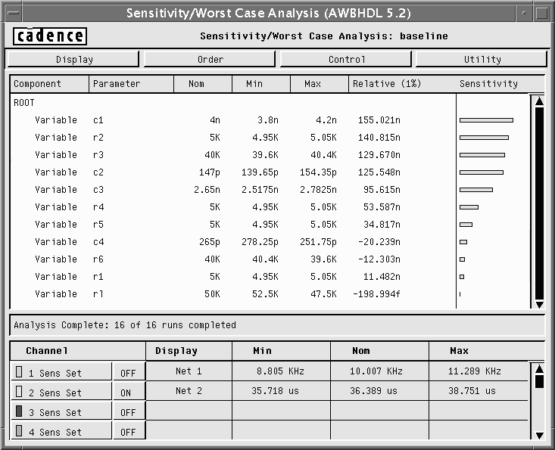
Figure 15. Sensitivity/Worst Case Analysis of Baseline Circuit

The simulation time for the Sensitivity/Worst Case was 16 seconds and the 1000 run Monte Carlo analysis was 16 minutes and 40 seconds.

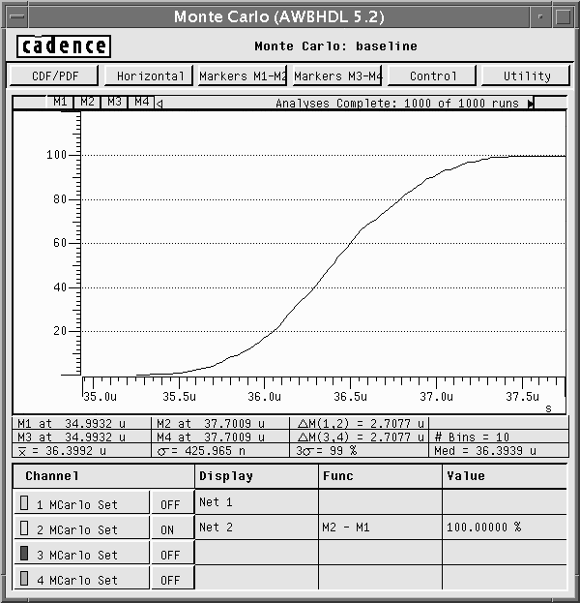
Figure 16. 1000 Run Monte Carlo Analysis of Baseline Circuit

Confirmation

Switching back to the alternate “Parameter Design Technique” a confirmation simulation is needed to predict the maximum group delay of the circuit. The results show that the resulting group delay for the Confirmation run is 38.92usec when all noise factors are at their maximum value (Figure 17). The simulation time for the Confirmation run was one second.

Figure 17. Confirmation Simulation Circuit and Results

Conclusions

The confirmation simulation circuit produced a worst case result that was greater than the 1000 run Monte Carlo but less than EVA Sensitivity/Worst Case. In this case, the Parameter Design Technique not only required fewer simulation runs but produced a more “worst case” result in less time than the Monte Carlo.

A comparison between the simulation times shows that the Parameter Design Technique required only nine seconds. While the EVA Sensitivity/Worst Case required sixteen seconds and the 1000 run Monte Carlo required 16 minutes and 40 seconds.

This is not to suggest that we abandon the classical approaches, because sometimes they will produce results that are more accepted by our customers and may show “true” worst case performance. However, in some cases an alternate approach may be acceptable to the customer and more cost effective.

Figure 18. Maximum Group Delay Comparison Chart

Figure 19. Simulation Times

Acknowledgements

We would like to express our appreciation to Eric Smith and George Adamczyk for allowing us to write this paper.

Appendix A – Simulation Circuits and Results

Figure A1 Baseline Circuit and Results
Figure A2 Ortho1 Circuit and Results
Figure A3 Ortho2 Circuit and Results
Figure A4 Ortho3 Circuit and Results
Figure A5 Ortho4 Circuit and Results
Figure A6 Ortho5 Circuit and Results
Figure A7 Ortho6 Circuit and Results
Figure A8 Ortho7 Circuit and Results

Figure A9 Ortho8 Circuit and Results

Figure A10 Confirmation Circuit and Results

Appendix B - Four Pole Transitional Butterworth-Thompson Lowpass Filter Design

The design of a Four Pole transitional Butterworth-Thompson lowpass filter is presented below in a step by step approach and uses MathCAD and Analog Workbench. The approach used is based on the article “Analysis and Synthesis of Transitional Butterworth-Thompson Filters and Bandpass Amplifiers” by Yona Peless and T. Murakami from the March 1957 RCA Review.

Step 1 - Selecting the desired “m” for the filter where “m” is the fulcrum value between a Butterworth’s “maximally flat amplitude (MFA) response and a Thompson’s maximally flat envelop delay (MFED). The selection of m allows for the compromise between the two types of filter responses.

In our case we will pick

m=0.8 #1

Figure B1 Four Pole Location of Poles, Coefficients and Normalized Scale Factors

Step 2 - Deriving the Transfer Function starts with the 2πB term of 0.712 in Figure B1. This term defines how the f₀ will be modified based on the “m” selection to achieve the desired 3dB bandwidth. In our case we would like

$f_{0}=\text{10}\text{KHz}$ #2

Thus, the filter that needs to be designed needs to have a scaled bandwidth of

$\frac{f_{0}}{2πB}=\text{14}\text{KHz}$ #3

or

$ω_{n}=(2π)\text{14}\text{Krads}\text{/sec}$ #4
The 4th order lowpass transfer function will take the form

$H(s)=\frac{1}{s^{4}+b_{3}s^{3}+b_{2}s^{2}+b_{1}s+1}$ #5

where, from Figure B1, we see the coefficients for b₁, b₂ and b₃ are

$b_{1}=3\text{.}\text{0943}$ #6
$b_{2}=4\text{.}\text{2033}$ #7

and

$b_{3}=3\text{.}\text{0256}$ #8

To scale the transfer function for the desired ω_{n} the coefficient must be scaled. Thus,

$H(s)=\frac{A_{0}}{s^{4}+A_{3}s^{3}+A_{2}s^{2}+A_{1}s+A_{0}}$ #9

where

$A_{0}=ω_{n^{4}}=5\text{.}{\text{987*10}}^{\text{19}}$ #10
$A_{1}=b_{1}ω_{n^{3}}=2\text{.}{\text{106*10}}^{\text{15}}$ #11
$A_{2}=b_{2}ω_{n^{2}}=3\text{.}{\text{252*10}}^{\text{10}}$ #12
$A_{3}=b_{3}ω_{n}=2\text{.}{\text{661*10}}^{5}$ #13

and produces
$H(s)=\frac{5\text{.}\text{987}∗{\text{10}}^{\text{19}}}{s^{4}+2\text{.}\text{661}∗{\text{10}}^{5}s^{3}+3\text{.}\text{252}∗{\text{10}}^{\text{10}}s^{2}+2\text{.}\text{106}∗{\text{10}}^{\text{15}}s+5\text{.}\text{987}∗{\text{10}}^{\text{19}}}$ #14

Step 3 – Simulating the transfer function in Analog Workbench shows that the 3dB point for the lowpass filter matches the desired 10KHz frequency.
Figure B2 Transfer Function Simulation Circuit

Figure B3 Transfer Function Response

Step 4 – Next a circuit must be synthesized which meets the transfer function desired. To do this we will break the filter into two second order filters which are of the Delyiannis-Friend or Multi-Feedback topology.

Figure B4 Delyiannis-Friend Lowpass Filter

The transfer function for the two pole low pass filter shown in Figure B4 is

$\frac{\text{Vout}}{\text{Vin}}=\frac{−\frac{1}{R1R2C3C5}}{s^{2}+\left[\frac{1}{R1C3}+\frac{1}{R2C3}+\frac{1}{R4C3}\right]s+\frac{1}{R2R4C3C5}}$ #15

From Figure B1 we know where the roots of the denominator are and will pick the first complex conjugate pair and build the first 2nd order filter. The first roots are at

$$P1,P2=−0\text{.}\text{6034}±j0\text{.}\text{8553}$$

$h(s)=(s+0\text{.}\text{6034}+j0\text{.}\text{8553})∗(s+0\text{.}\text{6034}−j0\text{.}\text{8553})$ #16

which can be expanded to a quadratic form as

$h(s)=s^{2}+1\text{.}\text{207}s+1\text{.}\text{096}$ #17

Associating coefficients implies

$1\text{.}\text{207}=\frac{1}{R1_{a}C3_{a}}+\frac{1}{R2_{a}C3_{a}}+\frac{1}{R4_{a}C3}$ #18

and

$1\text{.}\text{096}=\frac{1}{R2_{a}R4_{a}C3_{a}C5_{a}}$ #19

To achieve a unity gain at DC we will let

$R1_{a}=R4_{a}=1$ #20

and arbitrarily set

$R2_{a}=8$ #21

Thus,

$C3_{a}=\frac{1}{1\text{.}\text{207}}\left(\frac{1}{R1_{a}}+\frac{1}{R2_{a}}+\frac{1}{R4_{a}}\right)=\frac{2\text{.}\text{125}}{1\text{.}\text{207}}=1\text{.}\text{76085}$ #22

and

$C5_{a}=\frac{1}{1\text{.}\text{096}(R2_{a}R4_{a}C3_{a})}=\frac{1}{(1\text{.}\text{096})(8)(1)(1\text{.}\text{76085})}=0\text{.}\text{0648}$ #23

Next we want to apply frequency scaling to move the 3dB point to the desired location and scale the parts to reasonable values.

For the resistors we will multiply them by 5000 so

$R1_{a}=R4_{a}=5kΩ$ #24

and

$R2_{a}=\text{40}kΩ$ #25

The capacitors likewise can be scaled but must also be scaled relative to the desired 14KHz.
Thus,

$C3_{a}=\left(\frac{1\text{.}\text{76085}}{\text{5000}∗2π∗\text{14}\text{KHz}}\right)=\text{4000}\text{pF}$ #26

$C5_{a}=\left(\frac{0\text{.}\text{0648}}{\text{5000}∗2π∗\text{14}\text{KHz}}\right)=\text{147}\text{pF}$ #27

From Figure B1 we know where the roots of the denominator are for the second complex conjugate pair and build the second 2nd order filter. The second roots are at

$P3,P4=−0\text{.}\text{9094}±j0\text{.}\text{2925}$ #28

$h(s)=(s+0\text{.}\text{9094}+j0\text{.}\text{2925})∗(s+0\text{.}\text{9094}−j0\text{.}\text{2925})$ #29

which can be expanded to a quadratic form as

$h(s)=s^{2}+1\text{.}\text{819}s+0\text{.}\text{913}$ #30

Associating coefficients implies

$1\text{.}\text{819}=\frac{1}{R1_{b}C3_{b}}+\frac{1}{R2_{b}C3_{b}}+\frac{1}{R4_{b}C3_{b}}$ #31

and

$0\text{.}\text{913}=\frac{1}{R2_{b}R4_{b}C3_{b}C5_{b}}$ #32

To achieve a unity gain at DC we will let

$R1_{b}=R4_{b}=1$ #33

and arbitrarily set

$R2_{b}=8$ #34

Thus,

$C3_{b}=\frac{1}{1\text{.}\text{819}}\left(\frac{1}{R1_{b}}+\frac{1}{R2_{b}}+\frac{1}{R4_{b}}\right)=\frac{2\text{.}\text{125}}{1\text{.}\text{819}}=1\text{.}\text{168}$ #35

and

$C5_{b}=\frac{1}{0\text{.}\text{913}(R2_{b}R4_{b}C3_{b})}=\frac{1}{(0\text{.}\text{913})(8)(1)(1\text{.}\text{168})}=0\text{.}\text{1172}$ #36

Next we want to apply frequency scaling to move the 3dB point to the desired location and scale the parts to reasonable values.

For the resistors we will again multiply them by 5000 so

$R1_{b}=R4_{b}=5kΩ$ #37

and

$R2_{b}=\text{40}kΩ$ #38

The capacitors likewise will be scaled. Thus,

$C3_{b}=\left(\frac{1\text{.}\text{168}}{\text{5000}∗2π∗\text{14}\text{KHz}}\right)=\text{2560}\text{pF}$ #39

$C5_{b}=\left(\frac{0\text{.}\text{1172}}{\text{5000}∗2π∗\text{14}\text{KHz}}\right)=\text{267}\text{pF}$ #40

Step 5 – Next, we build and simulate the four pole filter and compare the results to the expect response. As can be seen there is a very close 3dB match between the expected response and the circuit response.

Figure B5 Synthesized Four Pole TBT Lowpass Filter

Figure B6 Synthesized TBT and Ideal Responses

