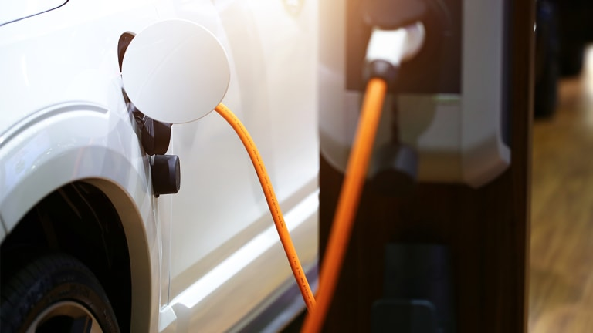

EVolution
  - Electric vehicles: The history, technology and future
Nick Rupert | EECT 279 | December 2019

Intro
It is a common human quality to wonder what the future holds. A look back at films from decades ago will show depictions of future times with flying cars and wild outfits – all a product of our ingenuity and imagination. Lucky for us, the future is happening right before our eyes in the form of electric vehicles (EVs). It wasn’t long ago that the thought of getting 35 miles per gallon was an impressive feat. Now, vehicles like the Nissan Leaf can roll right past you without making a sound.
EVs are one of the most exciting developments in modern technology simply because of how it can affect our future methods of travel. Imagine parking your car in your garage after work and putting it on the charger, much like your smart phone. Millions of people are already experiencing this phenomenon, and studies suggest that number will continue to grow. From 300+ miles of battery range to the acceleration of a Ferrari, EVs are the future and the technology is just getting started.

History
Though EVs seem to have just recently begun to make a spark in today’s automotive industry, the first EVs ever made were actually invented before 1900. In 1834, the first battery-powered EV was a tricycle built by Thomas Davenport (Chan and Chau, pg16). Davenport used Joseph Henry’s early electromagnet technology to develop what is widely considered as the first electric motor in the early 1830s. Using four electromagnets, Davenport put two on a pivot and two on fixed poles. He then used a battery attached to a commutator to supply current to the motor (“Thomas Davenport: Inventor of the DC Electric Motor”, ).
Electronic vehicles became more practical in the 1870s after the invention of the lead-acid battery in 1874. This allowed inventors to design rechargeable EVs with longer ranges and higher speeds. During this time period, EVs were highly-sought by the rich for their clean, quiet motors and cutting-edge technology. EVs competed with steam-powered horseless carriages and internal combustion engine vehicles (ICEV), which were notoriously loud and dirty (Chan and Chau, pg16).
By the final decade of the 19th century, there were several companies producing EVs in the US, Britain and France. The Electrobat, made by the Electric Carriage and Wagon Company, became popular in the 1894 streets of Manhattan, Philadelphia and Boston (Chan and Chau, pg16). Early designs of the Electrobat (Figure 1) looked similar to a Radio-Flyer wagon and hauled a 1,600-pound battery. By the fourth prototype, inventors Pedro Salom and Henry Morris made an Electrobat with a 350-pound battery and pneumatic tires that replaced its original steel tires (“The Great Electrobat”).
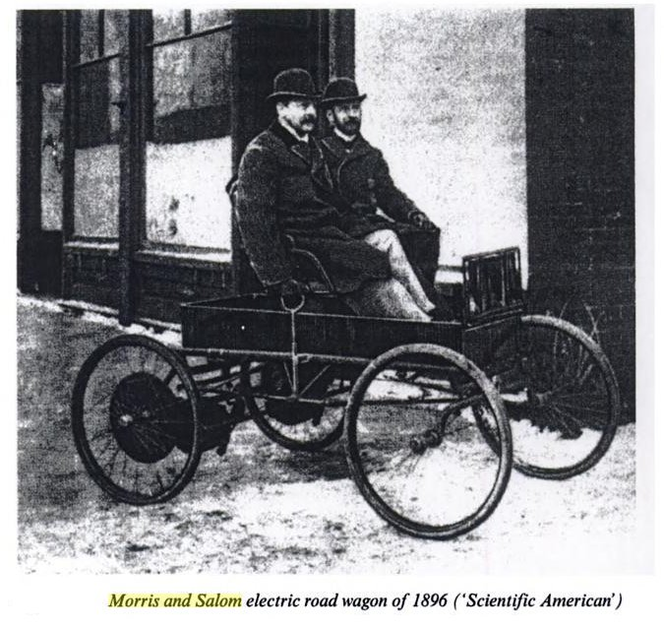
Figure 1
By 1912, about 34,000 EVs were registered in the US as the era of horseless carriages ended (Chan and Chau, pg17). EVs made by the British Electromobile Company of London featured rear-wheel drive and a wheel-steering system using two motors in 1920. By 1938, Detroit Electric released EVs badged as silent, clean and reliable with a top speed of 40 km/h (24.9 mph) and a max range of 129 km (80.2 miles) per charge (Chan and Chau, pg17-18).
Due to limitations in energy storage technology and the price of EVs, ICEVs quickly took over the personal transportation market in the mid-1900s. This was due in large part to Henry Ford and his manufacturing methods of the Ford Model T. Originally priced at $850 in 1909, manufacturing improvements helped lower the cost to $260 by 1925. ICEVs could then offer more than double the range of EVs at a fraction of the cost, which virtually eliminated EVs from the market by 1940 (Chan and Chau, pg18).
It wasn’t until the energy crisis and oil shortage in the 1970s that EVs began to regain interest in the minds of vehicle manufacturers. With the OPEC oil embargo in 1973, oil prices jumped by 350% and many gas stations were left without fuel. This helped spur a trend of energy awareness throughout the world, including new thermostats, light bulbs and EVs (“Energy Crisis”). The need for efficient vehicles was higher than ever, as well as separation from the world’s dependency on oil.

Today’s EV Technology
Ideas and developments from the last couple of centuries have come together to produce today’s EV technology. Because of different discoveries and theories, several types of vehicles aimed at efficient, clean transportation have come to fruition, including traditional battery-powered, hybrid-electric, fuel cell and metal-air battery vehicles (Laraminie and Lowry, pg8).
As a vehicle category with numerous technological variations, hybrid-electric vehicles have two or more power sources working together to create an ultra-efficient transport. Most of these HEVs combine a battery, IC engine, generator and an electric motor in either a series or parallel layout. In a series-hybrid system, shown in Figure 3, the HEV is driven by one or more electric motors powered by the battery and/or an IC engine. The IC engine does not power the wheels, though, and all wheel power is derived from the electric motors (Laraminie and Lowry, pg9).
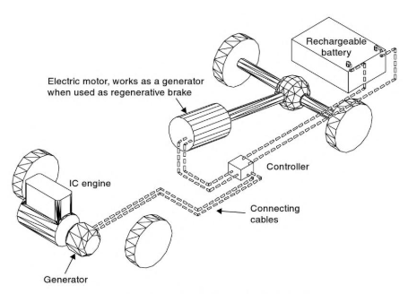
Figure 3
Parallel-hybrid vehicles can be driven directly by the IC engine through the transmission, by electric motor(s), or both. Regardless of the HEV’s drivetrain layout, the battery can be recharged while driving by both the IC engine and electric generator. This means HEVs can get by with much smaller batteries than a fully electric vehicle. Both HEV designs also allow for regenerative breaking (a form of frictionless breaking that recoups energy for use or storage) which also aids in lowering battery demands (Laraminie and Lowry, pg10).
As seen below in Figure 2, the basic layout of a rechargeable EV contains four main components: A rechargeable battery, controller, electric motor and transmission. The battery is normally recharged from mains electricity through a plug and charging unit that can either be carried onboard or fitted at the charging point (Laraminie and Lowry, pg8).
The EV’s controller works as a speed-regulator by controlling the amount of power supplied to the motor. It also can make the vehicle move forward or in reverse, also known as a two-quadrant controller. In today’s more advanced EVs, a four-quadrant controller gives the vehicle the ability of regenerative breaking (Laraminie and Lowry, pg8).
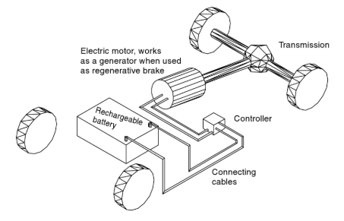
Figure 2

Modern EV Batteries
Today’s battery technology is really what makes modern EVs possible. Since the nearly one-ton, lead-acid battery that was lugged around by the Electrobat in the early 1900s, energy storage technology has improved immensely. The first non-rechargeable lithium-ion battery became commercially available in the 1970s, paving the way to modern rechargeable batteries used in a wide array of electronics today (“Understanding Lithium-ion”).
Lithium is the lightest of all metals and has the greatest electrochemical potential while providing the largest specific energy per weight. However, due to instability of lithium during charging, research suggested a non-metallic solution using lithium ions. This chemistry has turned out to be the most promising and fastest growing battery technology on the market (“Understanding Lithium-ion”).
Lithium-ion batteries use a cathode (positive) made of metal oxide, an anode (negative) made of porous carbon and an electrolyte as a conductor. The ions flow from the anode to the cathode during discharge through the electrolyte and separator. Charge then reverses direction and ions flow the other way due to the oxidation of the anode (loses electrons) and reduction of the cathode (gains electrons) (Figure 4).
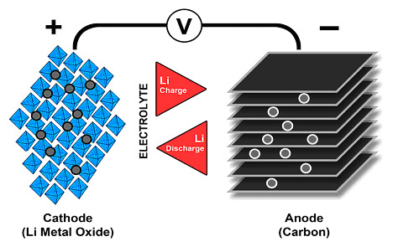
Figure 4
Though battery technology is improving, it still remains the most expensive component of modern EVs. For example, a battery with luxuries such as a cobalt-oxide cathode, graphite anode and liquid lithium salt electrolyte costs about $45 per kilogram to manufacture. This means a good, commercial-grade battery for an EV would easily exceed $13,500. This cost is high compared to the manufacturing cost of the drivetrain of mass-market, hydrocarbon-fueled vehicles (Lee and Clark, pg12).
The longest range EV on the road today is the Tesla Model S, which packs a 100-kWh lithium-ion battery. At full charge, the Model S can go about 370 miles before needing a recharge at a Tesla charging station. At 240V, the battery takes about 11 hours and costs about $15.29 to reach a full charge. Luckily, Tesla has installed a wide variety of games and entertainment into its dash to keep a driver occupied during charging (“10 Longest-Range Electric Cars of 2019”).

Modern EV Motors
A major player in what makes EVs so efficient, quiet and surprisingly fast is the electric motor technology supplying power to the wheels. Today’s EVs typically use three-phase, four-pole inductor motors that contain two main parts: a stator and a rotor. The stator core is a group of steel rings that are insulated from one another and laminated together. Conducting wire is then wrapped around these rings to form stator coils. Energy is supplied to the stator by the battery, which creates an electromagnetic field within the stator coils. This field pulls the conducting rods of the rotor, creating a spinning release of mechanical energy (“How an Electric Motor Works in a Car”).
Since a magnetic field is what drives the rotor in an electric motor, it is far more efficient than a typical IC engine. IC engines rely on small explosions to force movement of metal parts moving against other metal parts, causing lots of friction. Though we curb this friction with lubrications like motor oil, there is still a large amount of heat created. So much so, that an IC engine also needs to drive its own coolant system to keep it from overheating. Heat, vibration and loud noise are all signs of energy loss. These energy losses are far less significant in electric motor systems.
Electric motors are also more powerful than typical IC engines. This is because electric motors create more torque at lower speeds and do not need to shift through gears to get a car up to speed (Chan and Chau0, pg2). As electric motor technology improves, even the lower cost models of EVs will be as fast as high-end muscle cars with 8-cycliner IC engines.
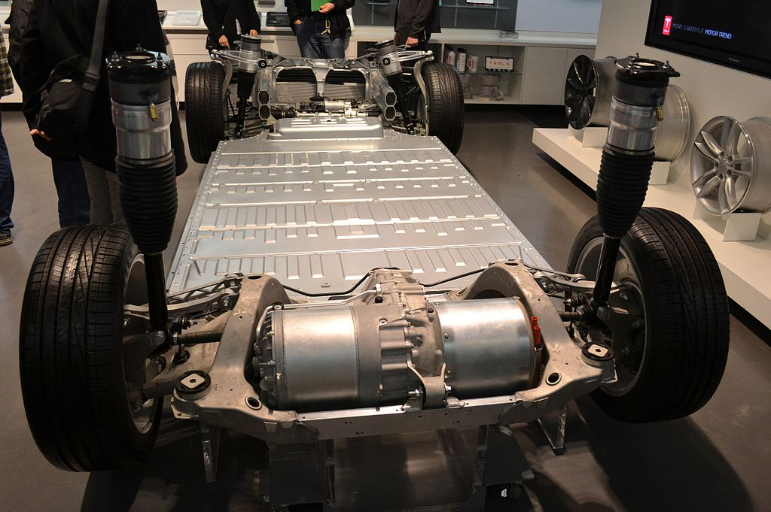
Tesla Model S drivetrain

The Future
With a bright light shining on clean energy options and flashy technology advancements, EVs are positioned to grow in popularity and affordability in the near future. Battery cell costs are estimated to fall due to advancements and large-scale productions. As EVs continue to become more common, charging station infrastructure is expected to grow as well (Chan and Chau, pg2).
Governments have enacted subsidy programs to support the installation of a charging infrastructure, and are starting to develop regulatory initiatives to support and manage an electric vehicle fleet. In fact, some governments—including the United Kingdom and France—have announced that they will not permit the sale of new fossil-fueled automobiles after 2040 (Chan and Chau, pg4).
Tesla is far from the only manufacturer to ramp up EV production in recent years. Volkswagen expects to offer 30 all-electric EVs by 2025, making up 25% of all new sales, while Ford is working to produce 13 models by 2022. A coalition of eight US states, including California, is aiming for a total of 3.3 million EVs on their roads by 2025 (Chan and Chau, pg9).
Though we are far from eliminating the ICEV from the automotive market, an observer should notice the abrupt rise in EVs on the road today. As manufactures find ways to drive down production costs and make EVs more affordable to the general public, the overall simplicity, efficiency and convenience of electric cars should drive more consumers to take the EV leap.

Sources
1. 10 Longest-Range Electric Cars of 2019. Kelley Blue Book. https://www.kbb.com/car-reviews-and-news/top-10/longest-range-electric-cars/2100006708/?slide=1. Accessed Dec. 2019.
2. Chan, C.C., and K.T. Chau. Modern Electric Vehicle Technology. Oxford Science Publications, 2001.
3. Energy Crisis. National Museum of American History, Behring Center. https://americanhistory.si.edu/american-enterprise-exhibition/consumer-era/energy-crisis. Accessed Dec. 2019.
4. How an electric motor works in a car. ElectricMotor Engineering. https://www.electricmotorengineering.com/an-electric-motor-works-car/. Accessed Dec. 2019.
5. Laraminie, J. and J. Lowry. Electric Vehicle Technology Explained. Wiley, 2003.
6. Lee, Henry, and Alex Clark. Charging the Future: Challenges and Opportunities for Electric Vehicle Adoption. Harvard Kennedy School, 2018.
7. Morris, David. Tesla Veteran Explains How Electric Motors Crush Gas Engines. Fortune. https://fortune.com/2015/11/17/electric-motors-crush-gas-engines/. Accessed Dec. 2019.
8. Thomas Davenport: Inventor of the DC Electric Motor. Edison Tech Center. https://edisontechcenter.org/DavenportThomas.html. Accessed Dec. 2019.
9. The Great Electrobat. The Woodlands. http://woodlandsphila.org/blog/2016/1/22/the-great-electrobat. Accessed Dec. 2019.
10. Understanding Lithium-ion. Battery University. https://gcep.stanford.edu/pdfs/assessments/ev_battery_assessment.pdf. Accessed Dec. 2019.

